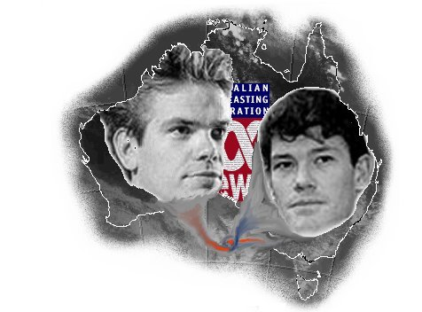
“Murder by Media – Death of Democracy in Australia”

by Scott Balson

NOW BANNED IN AUSTRALIAN BOOKSHOPS:
Quote from Dymocks bookshop letter dated 12th February 1999:
"I note your comment that the book cannot be the subject of legal threats because "it is based on fact and what reporters have written over the last three years". Even if that is in fact the case, we have been advised that truth alone is not a defence to defamation actions in Australia."

This is a book that had to be written. The book contains a number of chapters including the politics of power, media lies and distortions and compares the Australian experience on issues like political correctness to that in the USA.

The author is Pauline Hanson’s One Nation web master who has used three years of research on the Internet to compile this comprehensive expose on the Murdoch/Packer duopoly.

What you will read in this book will shock, sicken and sadden you. There is a solution, this is discussed in the book.

The book runs to about 260 pages and includes over forty historic full colour photographs.

More details on-line at: http://www.gwb.com.au/murder.html

Cut here:.......................................................................................

Please post this order with your payment made out to:
S Balson to P.O. Box 91, Wellers Hill, 4121 QLD

Your Name:........................................
Your Address:.............................................................................
Your Email address (if applicable):.................................
Your phone number:........................ Fax number:...................

Yes, please send me ........ copies of “Murder by Media” at Au$25 (US$20) per copy (add $5 for postage and handling to your order ie Au$30 (US$25) for 1 copy, Au$55 for 2 copies).

I enclose my payment of............... for ........... copies. Please allow 14 days for delivery.

Signed:..........................................

